**MOOC1**

**Week 1**

**Learning objectives for MOOC1**

3.Critically evaluate the reliability of sources for an academic context.

4.Filter, manage and organize information from a wide variety of sources for use in academic study.

5.Demonstrate awareness of ethical issues related to academic integrity surrounding the access and use of information.

**Academic culture**

**Core value of accademic culture:**

**Academic integrity, Independent learning, Critical thinking, Intellectual inquiry & information, Assessment, Ethical contribution,**

* the contingent nature of knowledge
* the importance of scholarly rigor and the need to be able  to explain to others with care and precision on whose work we're drawing
* the recognition that knowledge, discovery and sharing is a collective enterprise.
* a recognition that understanding is enhanced through the bringing together of different perspectives

quality of academic culture

3 ways that information and digital literacy contribute to the values of academic culture. (1.2b)

* Importance of finding good evidence to back up the ideas that you have
* The flexibility to change your opinion on an issue based on evidence to the contrary
* The importance of using academic journal databases to find information.

**information and digital literacy in academic culture**

* giving you the capacity to learn, apply your thinking, being able to problem solve, respond creatively to issues, communicate effectively with a range of different users because you need to be able to write, how do you communicate

Brick's definition of academic culture as the attitudes, values, and ways of behaving that are shared by a group of people who work or study in universities,

Information literacy in an academic context relates to information and how we decide what **information we need**, **find**, **evaluate**, **select**, **discard**, **use** and **store**

**Digital literacy:** Using digital tools. We then also need to add all those extra elements that relate specifically to the digital space such as being able to use digital tools to create information, communicate effectively, to manage your digital identity online, and to use digital networks to enhance your own learning. And of course we need to know how to do all this in a way that's appropriate to the academic context.

**Survival Skills for University**

Study skills

Time management

Collaboration

Keeping an opened mind

Questioning

Noticing

**Academic Integrity**

it refers to behaving honestly, ethically and responsibly within the academic context, in relation to the scholarly work that you produce.

Central values: **honesty, trust, fairness, respect, responsibility** and the courage to act on these values

**Acedemic misconduct -** breach of academic honesty

Plagiarism

self-plagiarism or re-submission

cheating: dishonest, unfair, disrespectful

fabrication or falsification of data or results: dishonest, untrustworthy, disrespectful

the facilitation of such actions of another student.

Helping another student to do these

**Week 2**

Information includes facts, details, descriptions, or a pre-existing analysis of a situational subject.

Knowledge, is a person's understanding of the situation or subject.

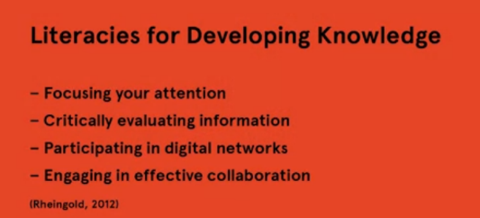

2 kinds of information: Cultural record, Scholarly record

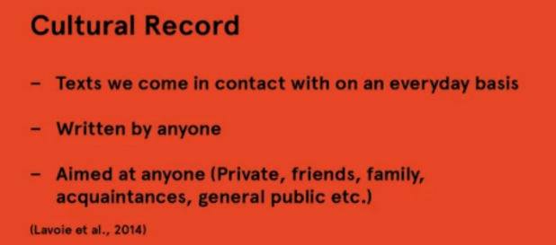

The scholarly record, on the other hand, has been defined as the curated account of past scholarly endeavor.

Curated refers to academic validation processes such as peer review and  publication.

Scholarly sources are typically written by experts and aimed at fellow experts or scholars in the field.

primary sources are those that give us a primary account, that is first hand information of an event.

Secondary sources are a step removed compared to primary resources and are an interpretation, analysis, or overview of a particular event. Secondary sources are written with hindsight and might be an analysis of the significance of a piece of pottery or an interpretation of a diary entry.

The last category tertiary sources give us an account that is twice removed.  Tertiary sources draw upon and summarize primary and secondary sources. Examples include things like handbooks, dictionaries, ncyclopedias, and textbooks

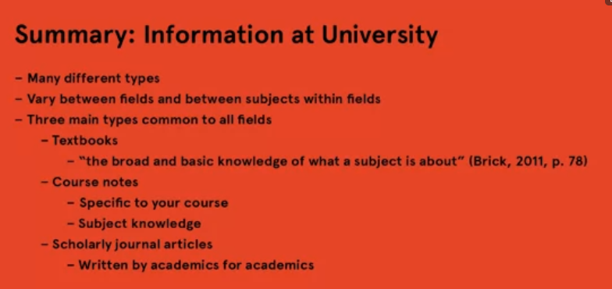

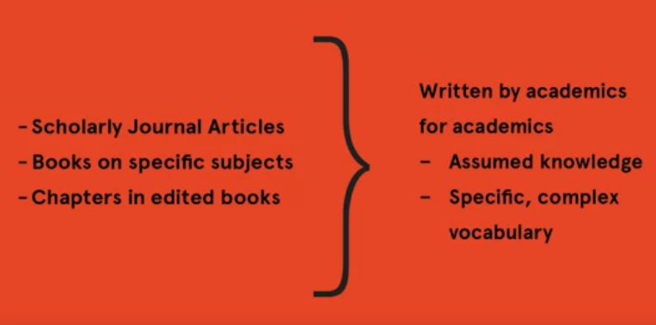

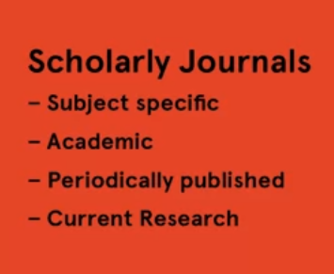

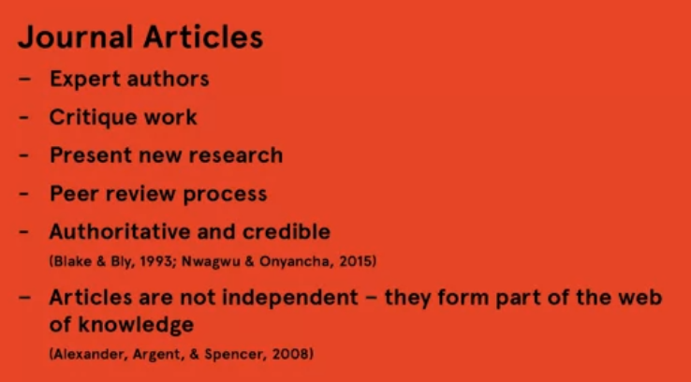

2 types of journal article

In Humanities: [2.2b How to Read a Journal Article in the Humanities | Coursera](https://www.coursera.org/learn/digital-literacy/supplement/PYGzZ/2-2b-how-to-read-a-journal-article-in-the-humanities)

In Science: [2.2b How to Read a Journal Article in the Sciences | Coursera](https://www.coursera.org/learn/digital-literacy/supplement/1DJjg/2-2b-how-to-read-a-journal-article-in-the-sciences)

Define Information need

Step 1: break down into sub-topics

Step 2: What information do you have already?

Step 3: What information do you need?

Step 4: Develop a set of search terms by thinking of synonyms for key terms in the questions

Step 5: Combine search terms to enter into databases and search engines

Step 6: Document your search strategy

+ Quotation mark

+ Synonyms

Boolean search terms, Date range, Related Articles, Citation chaining

**Week 3**

source credible,  Critically Evaluating Information

 six main factors

**Scholarly purpose**

**Authority:** Credibility, Reputation, Publisher

**Audience:** Academic

**Objectivity:** objective, non-biased, evidence based

**Accuracy:** accurate citation, authority of references

**Currency:** up-to-date

Critically Evaluating web resources

Additional factors:

**Publisher**

**Purpose:** goal of website, intended for, have a bias?

**Aesthetic and style:** well-organized, grammatically accurate

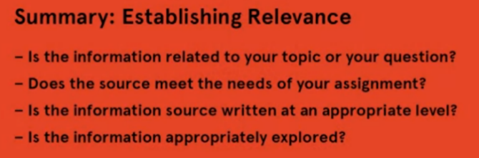**Referencing:** cited sources, link with reputable sites

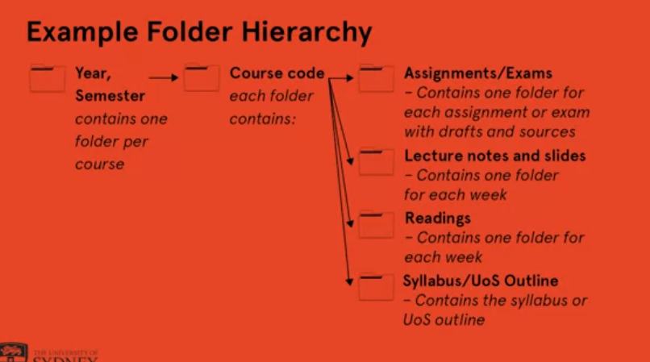**file-naming conventions, folder hierarchies:** Clear, Concise, Consistent, Chronological

**step 1:** system of naming files

Author surname_Year_keywords

e.g: Smith_2007_AI_economic_effects

YYYYMMDD_CourseCode_AssignmentDetail

YYYYMMDD_CourseCode_MaterialType

e.g: 20201110_JV101_LectureNotes

Unit of Study Outline / Syllabus

[_57f5dbc201bd1065daf1e98d174c90e2_3.3b-Guides-to-file-naming-conventions-and-folder-hierarchies---Reading.pdf (d3c33hcgiwev3.cloudfront.net)](https://d3c33hcgiwev3.cloudfront.net/_57f5dbc201bd1065daf1e98d174c90e2_3.3b-Guides-to-file-naming-conventions-and-folder-hierarchies---Reading.pdf?Expires=1619308800&Signature=TQkOmJtCHiw00BvgiVr0SZ4sQXuEppHlE1C5eUVotJAiNcTocskCx84nRu2PQV2CfmwQylJeW3KAz-9NMVz2uX~pVboig6pj-cB1p7u~yLbX1SvtqnSZ8XuBTshgjKwz2o8p~s3y6nBSn99WzWwhF6DMCfCuGLeZ2Z~h2DmdqQg_&Key-Pair-Id=APKAJLTNE6QMUY6HBC5A)

Put the name first (and et al. in this case as it’s by many authors)

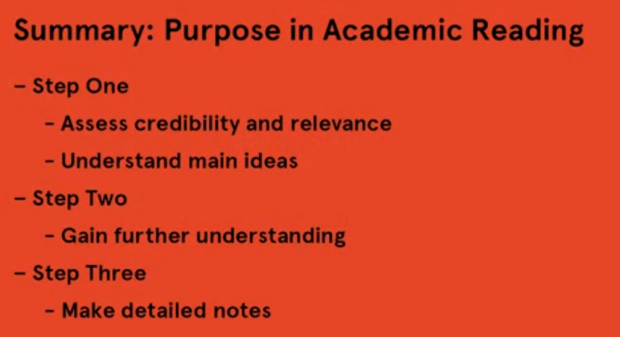

**WEEK 4**

# Avoiding Plagiarism

Plagiarism is using other people's work, things like other people's ideas, arguments and opinions, and claiming them as your own without giving proper credit to the people who thought of and created the information in the first place.

Plagiarism is a failure to acknowledge that the ideas or

information being presented derive from the work of others.

It is a serious form of academic misconduct.

Types of Plag:

**Unintentional:**

Unintentional plagiarism is accidental.

This is when students plagiarize without intending to do so, usually because of

a poor ability to reference or a poor understanding of referencing.

Or possibly because of an inability to paraphrase, or

simply because they were unaware of plagiarism rules.

**Intentional:**

Intentional plagiarism, or dishonest plagiarism,

as the University of Sydney calls it, is when a student or students deliberately

plagiarize others' work, and this is dealt with with much more severity.

Intentional plagiarism is a form of academic dishonesty.

Penalties range from failing the assignment through to legal action and

charges of fraud.

**Self-plagiarism** is when you reuse work that you've written for

a different purpose.

Referencing is a set of principles and practices used at university, and in fact

in all academic work, that allows you to acknowledge the work and ideas of others.

**things need to be referenced:**

* distinctive or unique ideas
* distinctive structure or organizing strategy.
* information or data, such as statistics, definitions, or laws
* verbatim phrase or passage
* a statistic, a quote, or any kind of fact that's outside of common knowledge
* when in doubt, reference the source.

# Referencing & Attributing Resources

A **referencing system** refers to any set of rules and guidelines for referencing.

A **referencing style** is the specific set of conventions, rules and guidelines fo referencing.

Types of referencing system:

Endnotes

Footnotes

In-text citing ( correspond to end-text)

Footnotes systems:

+ Abbreviation system: first is writen full, next in short

+ Name-date system: author’s family name, year of publishing

In-text citations:

+ Citation in the body of text: put name, date in brackets

+ Reference at the end of texts:

# Incorporating Sources

**Reason:** The first is to avoid plagiarism, shows your marker that you actually know what you're talking about, that you've done your research and that you understand the subject

# Quotes

Direct quotes are when you include a text exactly as it was written in another text using the author's voice.

Nhiều tác giả: First author, et al (=others, use when more than 6 authors)

# Paraphrasing and Summarising

**paraphrase**, you express someone else's writing in your own words, usually to achieve greater clarity.

**summarize**, you provide a brief statement of the main points of an article, web page, chapter, or book.

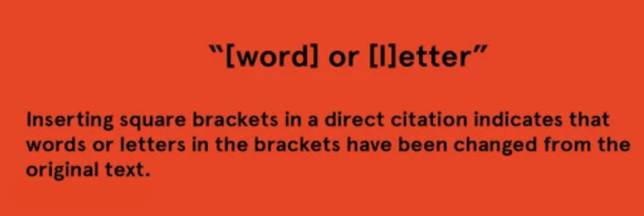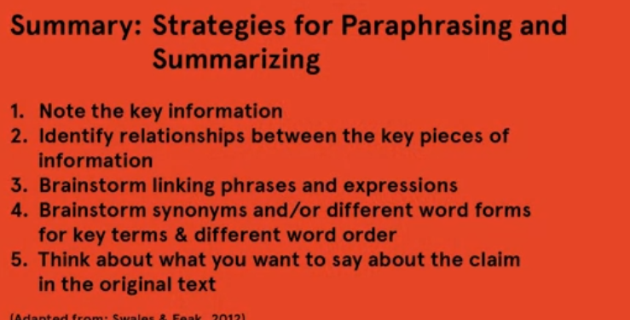In-text citation k có page number

[Summative - Module 4 | Coursera](https://www.coursera.org/learn/digital-literacy/exam/EURgp/summative-module-4/attempt?redirectToCover=true)

**WEEK 5**

# Copyright

Intellectual Property and under the umbrella of Intellectual Property, we find things like copyright laws, patents and trademarks. In this lesson, we will focus on copyright but what is copyright?

**Copyright:**  is a moral right and an economic right; governs our ability to use a work that someone own the copyrights.

Copyright and licensing affect student: infringement action, accessing and sharing resources, and the creation of works.

# Creative Commons Licencing

4 types of Creative Commons licensing

+ Attribution is where you need to reference the original creator, the title and the license the work is under.

+ The non-commercial license means the work cannot be used for commercial purposes such as advertising.

+ The non-derivative work license means that you can only have the baton copies of the work. That is, you cannot change it in any way.

+ the ShareAlike license stipulates that any new work produced using the material must be made available under the same licensing terms.

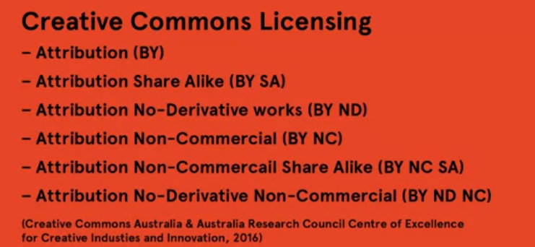

# Managing Digital Identity

online identity:

+ security: password management not sharing sensitive information across unsecure networks, among other things.

+ reputation.

3 types of online identity:

transactional identity: financial, insurance

social identity: personal data shared online,

professional identity: a positive image of our skills, experience, business offerings

Take ownership of online identity:

+ Have a public profile

+ expect unexpected audiences

+ Treat video, audio, image like texts

+ Obey the rules of netiquette

ELEVATOR PITCH

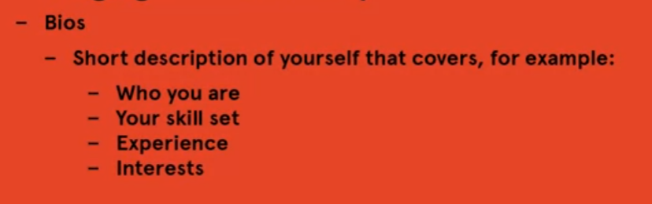

TWITTER BIOS

* professional but humanity
* Concise but not too simple
* Avoid buzzword (passionate, responsible, creative, motivated,…)
* Offer examples
* Avoid clichés

**MOOC 2**

**Objective:**

Apply problem-solving strategies to issues related to university life & study.

Recognize the importance & function of problem solving & creative thought within academic study.

**Academic culture:** the beliefs, principles and approaches to study, work and life that a university upholds

**Problem Solving:** is the process of overcoming obstacles to achieve a goal.

**Survival Skills for University:**

+ Take a broader persective

+ Get to know your university

+ Look after your own learning

+ Have confidence in yourself

**Academic Integrity**

**WEEK 2**

**Defining Problems**

three parts to a problem: initial state, solution path and goal

7 prob types:

* knowledge lean problems
* knowledge-rich problems
* well-defined problems
* ill-defined problems
* semantically lean problems
* semantically rich problems
* insight problems.

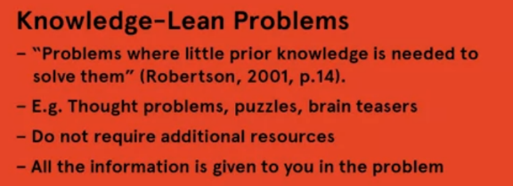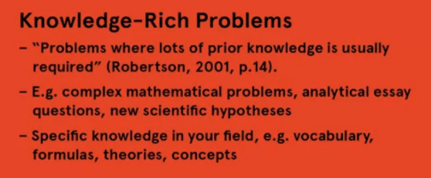

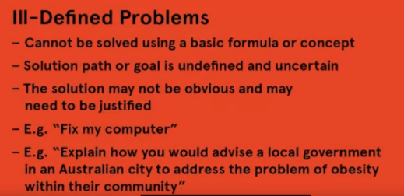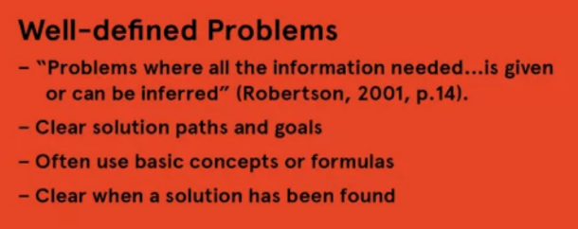

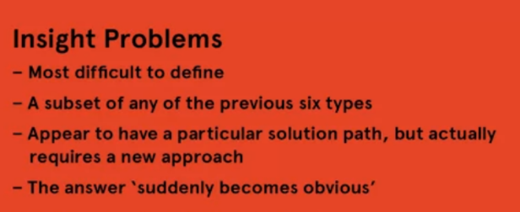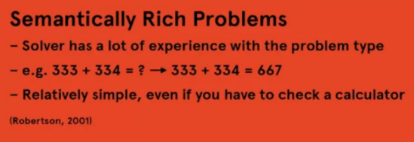

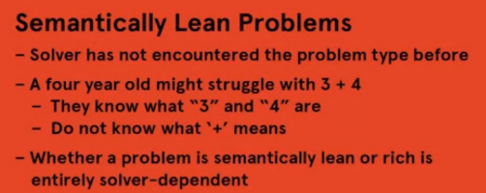

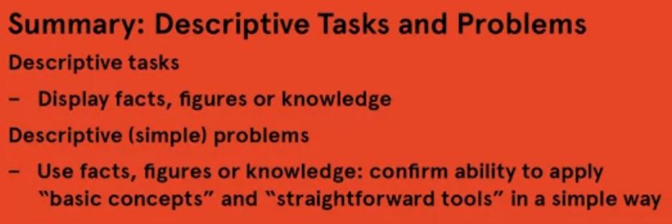

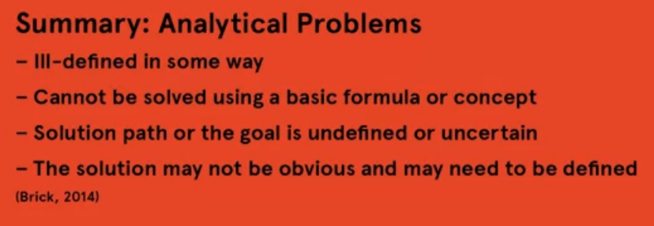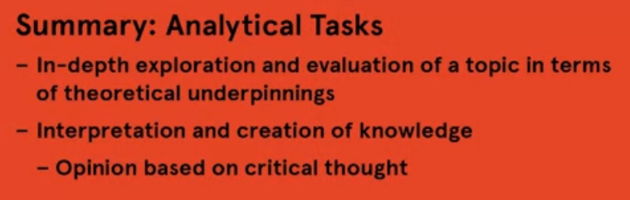

A descriptive task may ask you to summarize, state, illustrate, outline or explain.

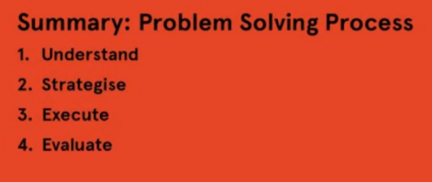An analytical task may ask you to such things as compare, contrast, describe, evaluate or critique.

Design thinking model

**What is**, involves to finding the initial state and the goal state and any blocks in between in order to understand the problem.

**what if** stage is where you generate as many possible solutions or alternatives to the problem as you can to imagine all of the different possibilities.

**what wow** section is where you call the solutions down to the ones that wow, that solve the problem in a nice, clean way.

**what works** is, as you would expect, where you use the reasoning you have done to create or implement the solution.

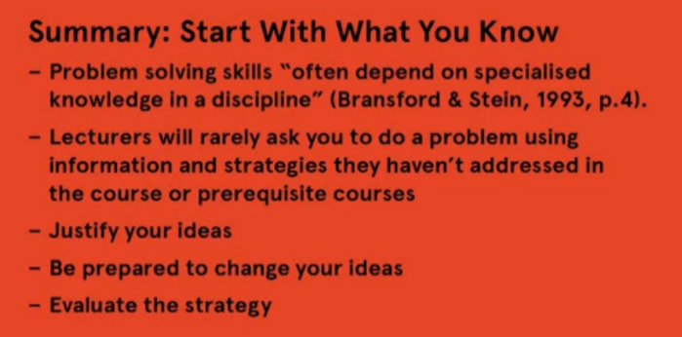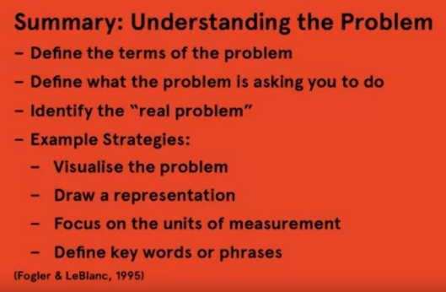**WEEK 3**

**Brainstorm**: is where you write down absolutely everything you know about a topic on a piece of paper.

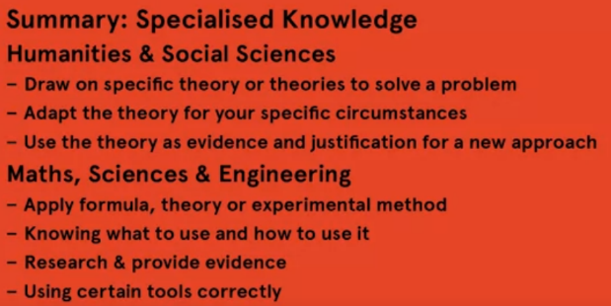**Mind map:** is where you write down key points on a piece of paper, draw lines between the main ideas showing how they connect to each other and the topic, and then write down evidence or extra information coming off each of the points.

**WEEK 4**

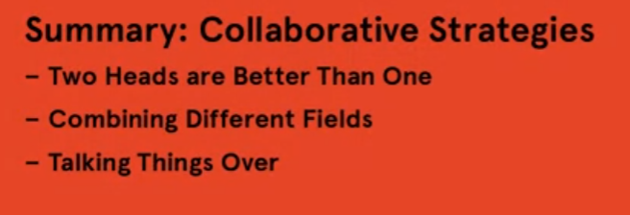Seeking Different Perspectives

Learning from Other People

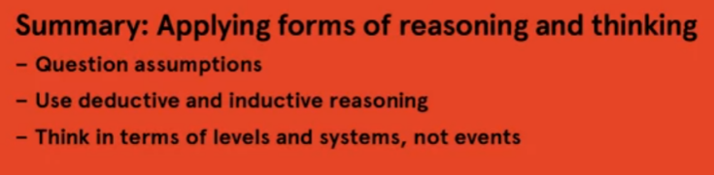Applying Forms of Reasoning and Thinking

Questioning Assumptions & Considering Alternatives

Using Creative Strategies

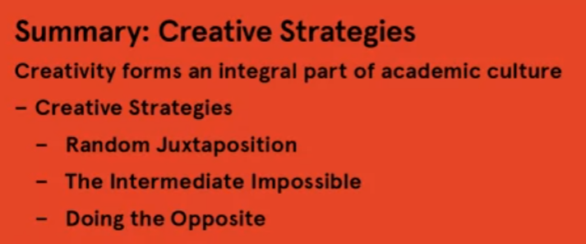

**Evaluating Solutions**

1. General methods

Create & decision statements

Decide on “musts” and “wants”

Create a list of objectives

Weight the objectives according to importance

Use objectives as criteria

1. Methods specific to academic culture

Don’t forget common sense

Use evidence

Make reference to ur knowledge

**Strategies Evaluating Solutions**

Reflecting on prob-sol process

Evaluating different possible sol

Evaluating ur ans use common sense

Checking and reflecing

# WEEK 5

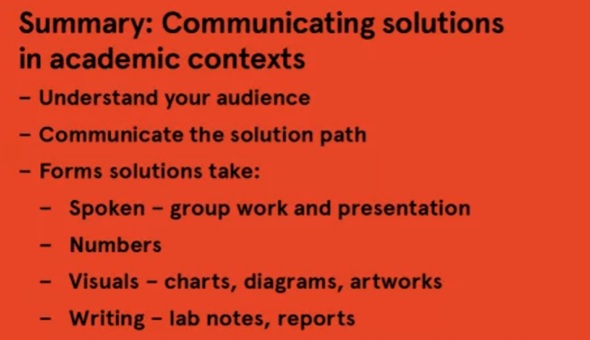**Communicating Solutions**

**Communicating Solutions in Written & Oral Form**

Communicate clearly and effectively

**Communicating Solutions in Exams**

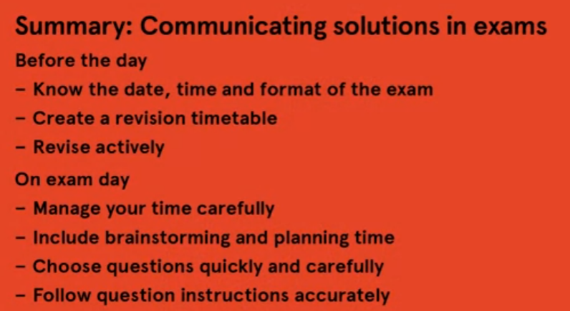

**Group Problem Solving**

characteristics of effective group work, interaction and structure.

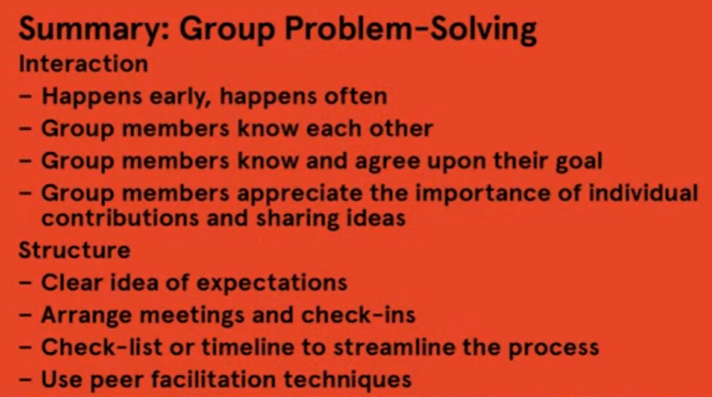

# 

**MOOC 3**

**WEEK 2**

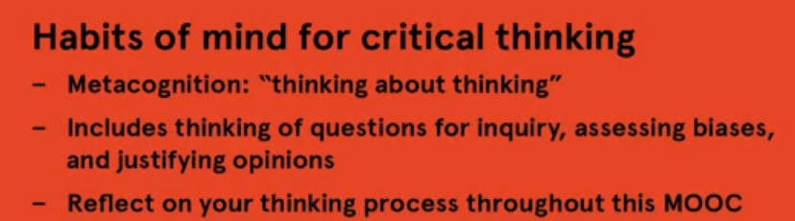**Dispositions & Habits of Mind for Critical Thinking**

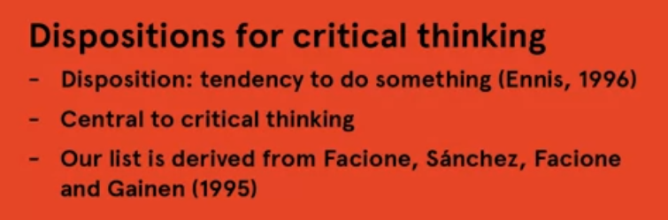

* inquisitiveness,
* being systematic in thinking
* truth-seeking
* self-confidence
* being analytical
* open-mindedness
* maturity

**Metacognition** is a reflection on our own thought processes

# Argument Spheres: Personal, Public, Technical (phạm vi lập luận)

Argument spheres are a way of conceptualizing differences in argumentation

# 

# Argument fields

+ correspond to different university fields of study such as law, literature, the sciences and so forth

+ share:

* 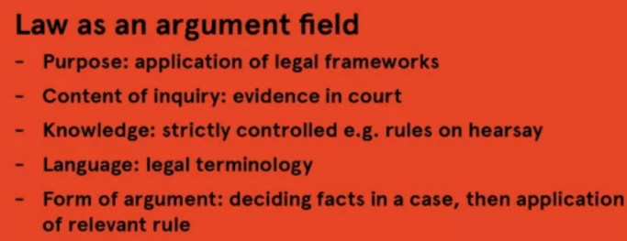a common object of study
* shared content of inquiry
* agreement on what contributes knowledge
* a specialised language
* processes of thought and inquiry

# Questioning in Critical Thinking

 A questioning stance is

+ a way of approaching any kind of text. Be it the conversation between you and your mother, a newspaper article, a piece of research, a theory, or even a lecture

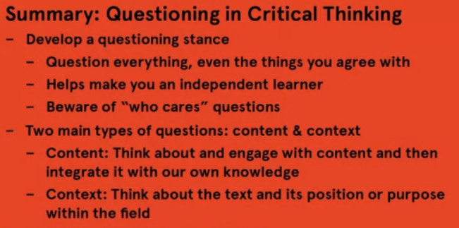+ a general approach to life and owning ur knowledge

**WEEK 3**

# Premises and Conclusions

# Argument: attempt to justify or prove a conclusion

**Conclusion:** What the author want you to believe, signed by “thus”, “therefore”, “so”

**Premise:** statements that are used as evidence, signed by because, cause, due

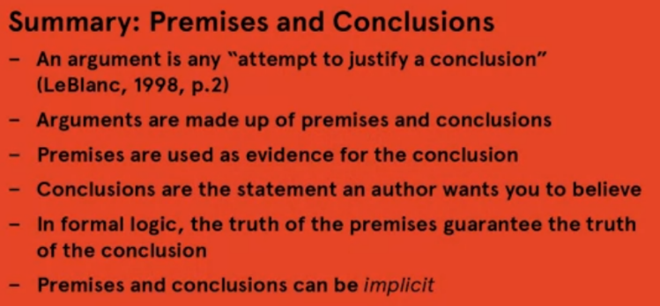

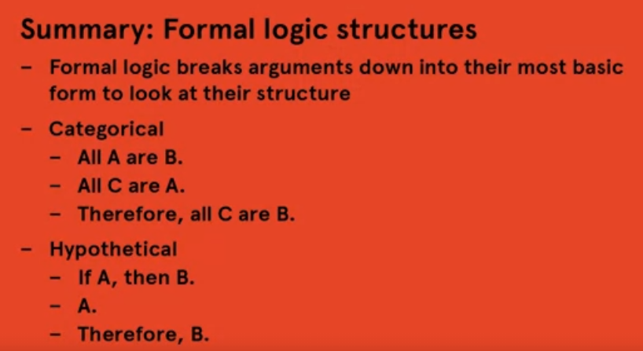

# Common Fallacies

# 

# Forms of Reasoning

# 

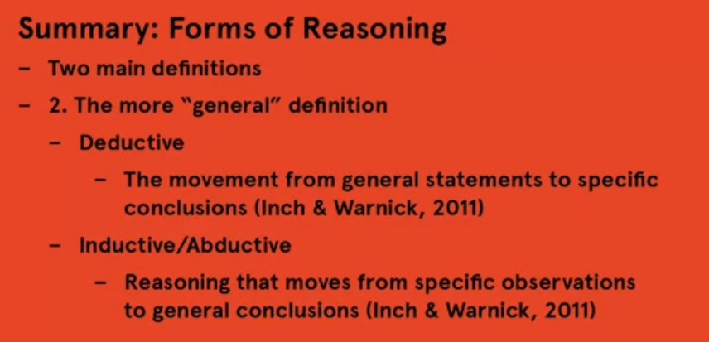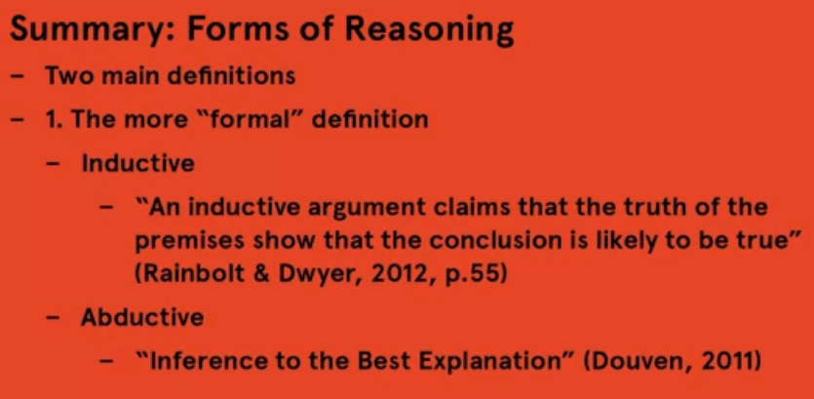

# Applying Systems Thinking

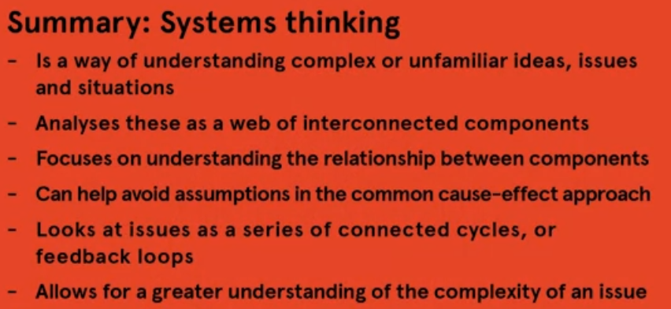

**WEEK 4**

# Claims and Evidence

# 

# Identifying Biases and Assumptions

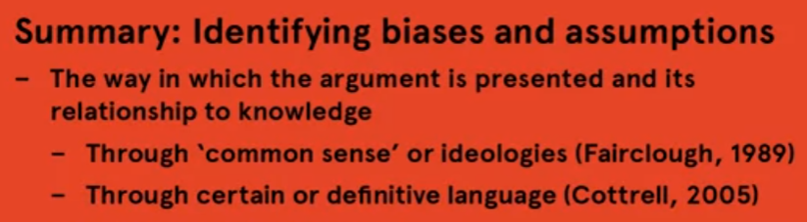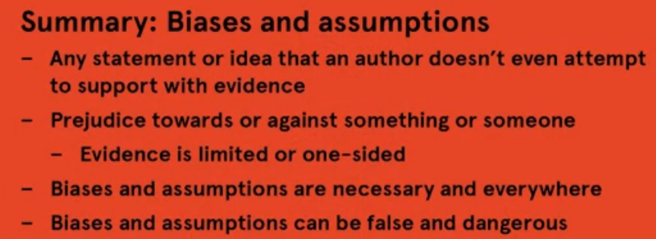

# Using Critical Thinking to Evaluate Arguments

# 

# Types of arguments

# 

# 2 similar things compare

**WEEK 5**

# Argument Structures

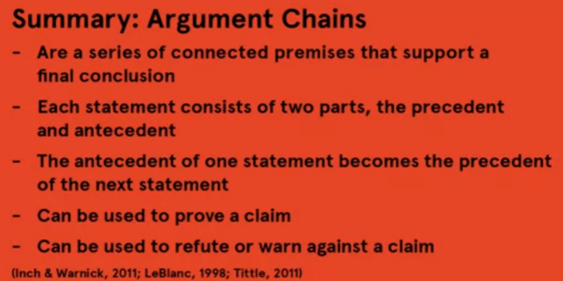

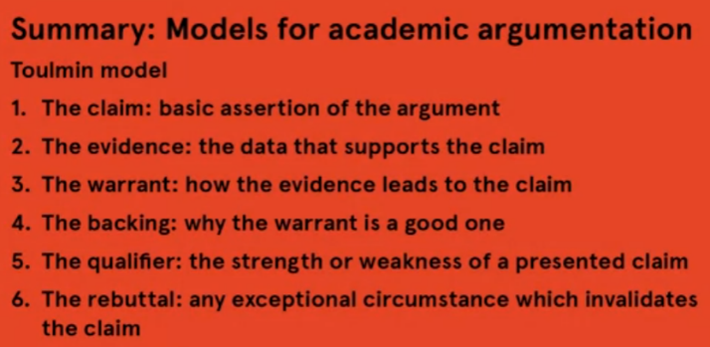**Model for academic argumentation**

Khẳng định cơ bản

**Claim, evidence, warrant, backing, qualifier, rebuttal**

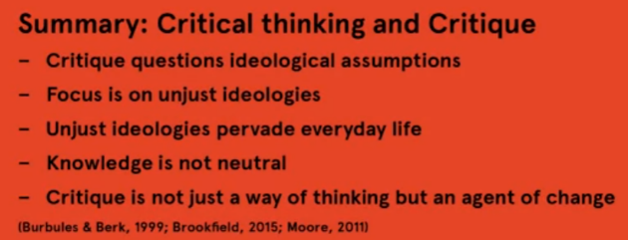**Critical Thinking and Critique**

Critique question ideological assumption

Focus is on unjust idelogies

Unjust ideologies pervade everyday life

Knowledge is not neutral

Critique is not just a way of thinking but an agent of change

[5.3a Critical Thinking and Critique | Coursera](https://www.coursera.org/learn/critical-thinking-skills/lecture/naxuJ/5-3a-critical-thinking-and-critique)

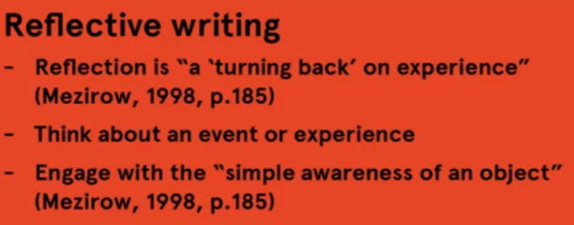**Reflective Writing**

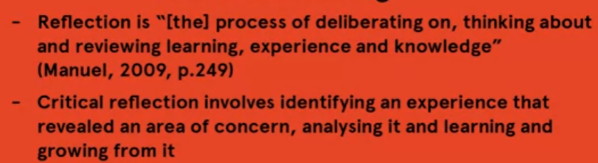

**MOOC 4**

**WEEK 2**

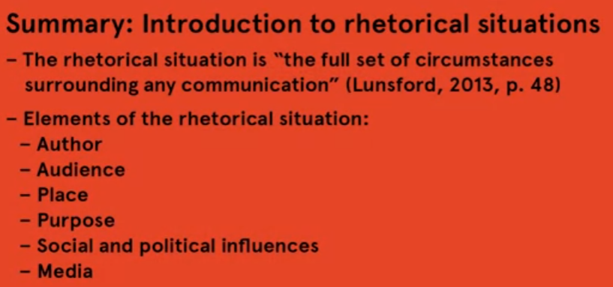**rhetorical situations**

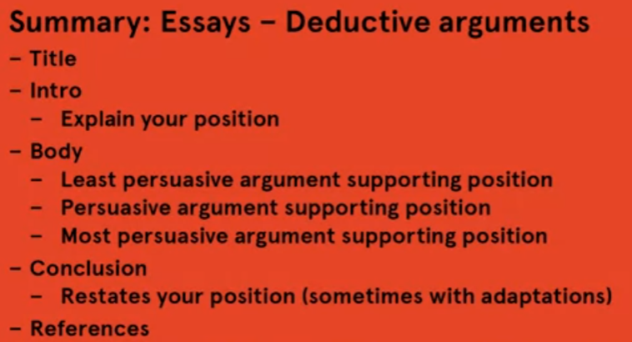**Participating in Lectures & Tutorials, Online forums**

